2019 Mission Month
Liturgy of the Word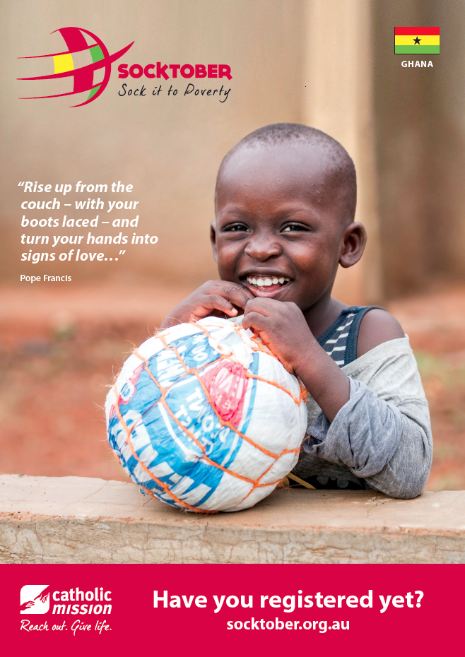

Venue:
Time:

Fear Not I Am With You
A Liturgy of the Word

Checklist of items and personnel required for this Liturgy:

ITEMS PERSONNEL
coloured fabric and boxes for a focus space. | Student to tap clapping sticks
clapping sticks | Student 1
a pair of jeans with the pockets pulled out | Student 2
a hessian bag | Leader of liturgy
a laminated photo of a tear drop (see below) | Student to carry jeans
squashed cardboard box | Student to carry hessian bag
an empty bowl | Student to carry tear drop
a candle | Student to carry cardboard
Baptised and sent poster | Student to carry empty bowl
a Mission Box | Student to carry Baptised and Sent poster
a school textbook, exercise book, pens, pencils | Student to carry candle
laminated picture flying dove (see below) | Student to be voice of Sr Stan
a pillow, folded towel, soap | Student to be voice of Sarah
bowl of fruit/rice | Student to be voice of Emmanuel
book holders to support laminated photos | First Reader Isaiah
lectern | Gospel Narrator
Book of the Gospels | Jesus
data projector | Leper
matches | Crowd 1
screen | Crowd 2
computer and sound amplification | Crowd 3
Catholic Mission PowerPoint resource | Crowd 4
❑ | Crowd 5
❑ | Student 1 to ask questions
❑ | Student 2 to answer questions
❑ | Student to place mission box
❑ | Student to place school textbook, exercise book and pencils
❑ | Student to place flying dove
❑ | Student to place pillow, towel, soap
❑ | Student to place bowl with fruit/rice
❑ | Prayers of Intercession 1
❑ | Prayers of Intercession 2
❑ | Prayers of Intercession 3
❑ | Prayers of Intercession 4
 | Prayers of Intercession 5
 | Student to work computer

Gathering

Acknowledgement of Country Please remain seated.
The clapping sticks sound at the door of the church and continue to sound as they are processed through the church to the front. The clapping sticks fall silent and the person playing them moves aside.

Setting the Focus Space
Student 1: The theme of World Mission Month 2019 is “Do not fear for I am with you.” Our focus country is Ghana, where the Church seeks to provide shelter, food, education, and life fulfilling opportunities for children in need, especially those with disabilities. Let us prepare a focus space.
Student 2: Ghana is a country of great natural beauty, with forests and waterfalls. Yet millions of people live in extreme poverty. We place a pair of jeans with the pockets pulled out.
A pair of jeans with pockets pulled out are placed on the focus space.
Student 1: Ghana is one of the world’s biggest producers of cocoa beans to make chocolate. Many of the farms use young children as child labourers who cut the cocoa pods and place them into bags to transport. We place a hessian bag, which is used to carry the cocoa beans.
A hessian bag is placed on the focus space.
Student 2: In the northern part of Ghana, some communities are unable to look after children with disabilities and these children struggle to survive.
We place a teardrop.
A large photo of a teardrop is placed on the focus space.
Student 1: In Ghana young children who are born to poor families often move away from home to become street kids. We place a sheet of cardboard.
A sheet of cardboard is placed on the focus space.
Student 2: In Ghana poor children who do attend school are often hungry for days at a time. We place an empty food bowl.
An empty bowl is placed on the focus space.
Student 1: This year marks an Extraordinary Mission Month, called for, by Pope Francis. This extraordinary Mission Month reminds us that we are “baptised and sent” to live the Gospel. We place a poster which shows a cross, in the colours of the continents, embracing the globe of earth.
A “Baptised and Sent” poster is placed on the focus space.
Student 2: In the Gospel of St John, Jesus says, “I have come that they may have life, life in all its fullness.”
A lit candle is placed on the focus space.
Student 1: That we may be informed of the good work of the Church in Ghana, let us watch a video presentation prepared by Catholic Mission.
Film is played.
Student 2: Please stand for our gathering hymn.

The Introductory Rites

Gathering Hymn Please stand
Sign of the Cross and Greeting
Leader: We gather as a community to be nourished by Christ in the Word proclaimed.
We gather as followers of Jesus called to life and mission.
We gather ... In the name of the Father, and of the Son, and of the Holy Spirit.
All: Amen.

Penitential Act
Leader: Let us acknowledge our individual and communal failings.
Sr Stan’s photo is displayed on the PowerPoint.
Voice of Sr Stan: My name is Sister Stan.
For ten years I have been managing Nazareth Home for God’s Children
I care for children who are orphaned.
Many of the children at Nazareth Home have disabilities.
At Nazareth Home the children find love, acceptance and hope.

Cantor: Lord Jesus, you are light for all.
You guide us on our way.
Lord, have mercy.
All sing: Lord, have mercy.
Sarah’s photo is displayed on the PowerPoint.
Voice of Sarah: My name is Sarah.
I am twelve years old.
I was born in northern Ghana.
I was born with a speech defect.
I struggled to survive in my community.
Sr Stan brought me into the care of Nazareth Home For God’s Children, where I am now thriving as one of the best students in the school.

Cantor: Lord Jesus, you are hope for all.
You take away our sins.
Christ, have mercy.
All sing: Christ, have mercy.

Child’s’photo is displayed on the PowerPoint.
Voice of Emmanuel: My name is Emmanuel, I am 10 years old.
Every morning I wake at 6am and get ready for a day of work in the cocoa fields. I don’t go to school.
I reach the fields at sunrise and use a machete to slice ripe cocoa pods from the tree.
Later I hack open the pods, and gather the beans which will be used to make chocolate
I make less than $1 per day.

Cantor: Lord Jesus, you are strength for all. Your word is truth and light.
Lord, have mercy.
All sing: Lord, have mercy.
© Richard Cootes 2014. Richard Cootes Music. Reprinted under One License #A-624954.
Slight pause before proceeding.

Collect
Leader: Let us pray.
Pause for silent prayer.
O God, you sent your Son into the world as the true light.
Pour out the Spirit he promised
that we may light the world with justice, joy, and hope.
We ask this through our Lord, Jesus Christ, your Son,
Who lives and reigns with you in the unity of the Holy Spirit,
one God, for ever and ever.
All: Amen.
Please be seated.

The Liturgy of the Word

First Reading
A reading from the Book of Isaiah (41:10, 17-20)
So do not fear, for I am with you;
do not be dismayed, for I am your God.
I will strengthen you and help you;
I will uphold you with my righteous right hand.
The poor and needy search for water,
but there is none;
their tongues are parched with thirst.
But I the Lord will answer them;
I, the God of Israel, will not forsake them.
The Word of the Lord.
All: Thanks be to God.
Pause in silence for personal reflection on the reading.
Responsorial Psalm - Sung
I Am Wonderfully Made Ps 138:1-3. 13-15.
I PRAISE YOU. I THANK YOU,
FOR I AM WONDERFULLY MADE.
I PRAISE YOU. I THANK YOU.
I PRAISE AND BLESS YOU, LORD,
FOR I AM WONDERFULLY MADE.

You search me. You know me.
You know my resting. You know my rising.
You search me. You know me.
All my ways lie open to you.

It was you, who made me,

Knit me together in my mother’s womb.
I thank you for my being,
For the wonders of all your creation.

You knew my soul, you knew my soul,
And my body held no secret from you,
When I was fashioned, in secret,
And molded in the depths of the earth.

© Richard Cootes. Richard Cootes Music. Reprinted under One License
Pause in silence for personal reflection.
Gospel Acclamation
The Book of the Gospels is held aloft and processed to the lectern as the Gospel acclamation is sung.
Alleluia (Your Word is Hope) Richard Cootes
Alleluia! Sing Alleluia! Alleluia to our God!
Alleluia! Sing Alleluia! Alleluia to our God!
Alleluia! Sing Alleluia! Alleluia to our God!
Alleluia! Sing Alleluia! Alleluia to our God!
Your word is hope!
Your word is life!
Your word is hope!
Your word is life!
Alleluia! Sing Alleluia! Alleluia to our God!
Alleluia! Sing Alleluia! Alleluia to our God! Alleluia to our God!
© Richard Cootes. Richard Cootes Music. Reprinted under One License #A-624954.
Please remain seated.

Gospel Please remain seated.

The proclamation of the Gospel is accompanied by a dramatic presentation.

Narrator: The Lord be with you.
All: And with your Spirit.
Narrator: A reading from the holy Gospel according to Mark (1:40-45 )
All: Glory to you, O Lord.

Narrator: A man with leprosy came to Jesus and begged him on his knees.

Leper: If you are willing, you can make me clean.

Narrator: Jesus was filled with compassion.
He reached out his hand and touched the man.

Jesus: I am willing! Be clean!

Narrator: Immediately the leprosy left him and he was cleansed.
Jesus sent him away at once with a strong warning:

Jesus: See that you don’t tell this to anyone. But go, show yourself to the priest and offer the sacrifices that Moses commanded for your cleansing.

Narrator: Instead he went out and began to talk freely, spreading the news. As a result, Jesus could no longer enter a town openly but stayed outside in lonely places. Yet the people still came to him from everywhere.

The Gospel of the Lord.

ALL: Praise to you, Lord, Jesus Christ.

Question and Answer Reflection
Student 1: What is a leper?

Student 2: In Hebrew and Christian Scripture a leper was a person with a skin disease. A leper could be a person afflicted with boils, sores, skin infections, or patchy scaly skin.

Student 1: How did the people of his community treat a leper?

Student 2: A leper was treated as an outcast… he was abandoned by the community. He was forced to live apart. He had to tear his clothes so that all would know he was a leper. He had to call out “Unclean. Unclean” to any one that came near him. He could not touch anyone, and no one was allowed to touch him. He could not even go near his own family.

Student 1: Were people afraid of catching leprosy?

Student 2: Yes. But you would also be considered ritually unclean if you touched a leper. That means you could not attend any religious rituals.

Student 1: Catholic Mission’s focus country this year is Ghana. Where is Ghana?

Student 2: Ghana is in West Africa, close to the Equator. Its neighbouring countries are Ivory Coast, Togo and Burkina Faso.

Student 1: Is it a poor country?

Student 2: Yes. Millions of people live in extreme poverty.

Student 1: What projects are the Catholic Church supporting in Ghana?

Student 2: The Church is supporting many projects. The two projects that support young children are the Mother of Mercies Baby Home and the Nazareth Home for God’s Children.

Student 1: What is the connection between our Gospel story of the leper and Ghana?

Student 2: In some parts of the north of Ghana children who are born with disabilities struggle to survive… like the leper in the story.
Many children with disabilities in northern Ghana do not have the opportunities to receive an education and learn skills that will enable them to be self sufficient and gain viable employment.

Student 1: What can we do to help?

Student 2: We can support the work of Sr Stan. Sr Stan and her team manage Mother of Mercies Baby Home and the Nazareth Home for God’s Children.
Sister Stan seeks out those children who are challenged by disabilities. She receives into her care those children who are orphans.
She makes sure that the children receive shelter, safety and loving care. She also tries to give children with disabilities the training and skills they need to lead fulfilling lives in their communities. Sr Stan is being Christ to those who are in desperate need of care, and is living witness of the proclamation of Isaiah: “Do not fear for I am with you.”

The following reflection hymn is sung.
Fear Not I Am With You Is 41:3,10/ Jn 14:27, 20-21/ Mt 28:20
Do not be afraid. Do not be afraid.
Fear not I am with you, Fear not I am with you,
Even till the end of time. Even till the end of time.
Do not be afraid. Do not be afraid
Fear not I am with you, Fear not I am with you,
Even till the end of time. Even till the end of time.
I have called you each by name, you are mine.
I have called you each by name, you are mine.

My own peace I leave with you.
My own peace I give to you.
Let it be the gift you share.
My peace, my peace for all the world.

Do not be afraid. Do not be afraid.
Fear not I am with you, Fear not I am with you,
Even till the end of time. Even till the end of time.
Do not be afraid. Do not be afraid
Fear not I am with you, Fear not I am with you,
Even till the end of time. Even till the end of time.
I have called you each by name, you are mine.
I have called you each by name, you are mine.

Just as the Father sent me.
So am I sending you.
Go now with the Gospel on your lips.
Go now with my joy in your hearts.

Do not be afraid. Do not be afraid.
Fear not I am with you, Fear not I am with you,
Even till the end of time. Even till the end of time.
Do not be afraid. Do not be afraid
Fear not I am with you, Fear not I am with you,
Even till the end of time. Even till the end of time.
I have called you each by name, you are mine.
I have called you each by name, you are mine.
© Richard Cootes. Richard Cootes Music. Reprinted under One License #A-624954.

Leader: As a sign of our commitment to support the work of Catholic Mission in Ghana, let us change the symbols on our focus space.

The following ritual takes place in silence.
Two students come forward from either side. The first takes the jeans form the focus space. The second replaces it with a Mission Box. They then move to stand together in the centre aisle holding the jeans, ready to process out.
Two more students come forward from each side. The first student takes away the hessian bag. The second student replaces it with a school textbook, exercise book, pens and pencils. They then move to stand together in the centre aisle holding the hessian bag, ready to process out.
Two more students come forward from each side. The first student takes away the picture of the teardrop. The second student replaces it with a picture of a dove. They then move to stand together in the centre aisle holding the teardrop, ready to process out
Two more students come forward from each side. The first student takes away the sheet of cardboard. The second student replaces it with a pillow, folded white towel and a bar of soap. They then move to stand together in the centre aisle holding the cardboard, ready to process out.
Two more students come forward from each side. The first student takes away the empty food bowl. The second student replaces it with a bowl filled with fruit/rice. They then move to stand together in the centre aisle holding the empty bowl, ready to process out.
Once all the students are standing in the centre aisle the Leader continues. The students process out of the church .

Prayers of Intercession Please stand.
Leader: It is our responsibility as God’s people to pray for the needs of the Church and the world. We pray for change: in ourselves and in the circumstances of those in need, particularly in Ghana.
Reader: For Pope Francis, that he will continue to show the compassion of Christ to the world.
Lord of Life, hear us.
All: Lord of life, hear our prayer.
For all children who are orphans, that they will be given safe refuge through the work of committed and loving carers.
Lord of life, hear us.
All: Lord of life, hear our prayer.
For all children in Ghana, and throughout the world, who are challenged by disability, that they will be given opportunities and skills that will lead them toward fulfilled lives.
Lord of life, hear us.
All: Lord of life, hear our prayer.
For all missionaries, that they will be inspired to continue the saving work of Christ.
Lord of life, hear us.
All: Lord of life, hear our prayer.
For all of us, that we will continue to be a source of life and love for all God’s children.
Lord of life, hear us.
All: Lord of life, hear our prayer.
Leader: God of all people, fill our hearts with your Holy Spirit that we will act justly to rid our world of all that harms our brothers and sisters. We ask this through Christ our Lord.
All: Amen.
Leader: Together let us say The Lord’s Prayer

All: Our Father, who art in heaven,
hallowed be thy name;
thy kingdom come,
thy will be done
on earth as it is in heaven.
Give us this day our daily bread,
And forgive us our trespasses,
as we forgive those who trespass against us;
and lead us not into temptation,
but deliver us from evil.

The Concluding Rite

Leader: Nourished by God’s Word, and moved by the Spirit of Jesus, let us go forth to proclaim God’s saving love to all. Please join in singing our final song.

Recessional Hymn
Final Hymn is Sung

