**[INSERT SCHOOL LOGO]**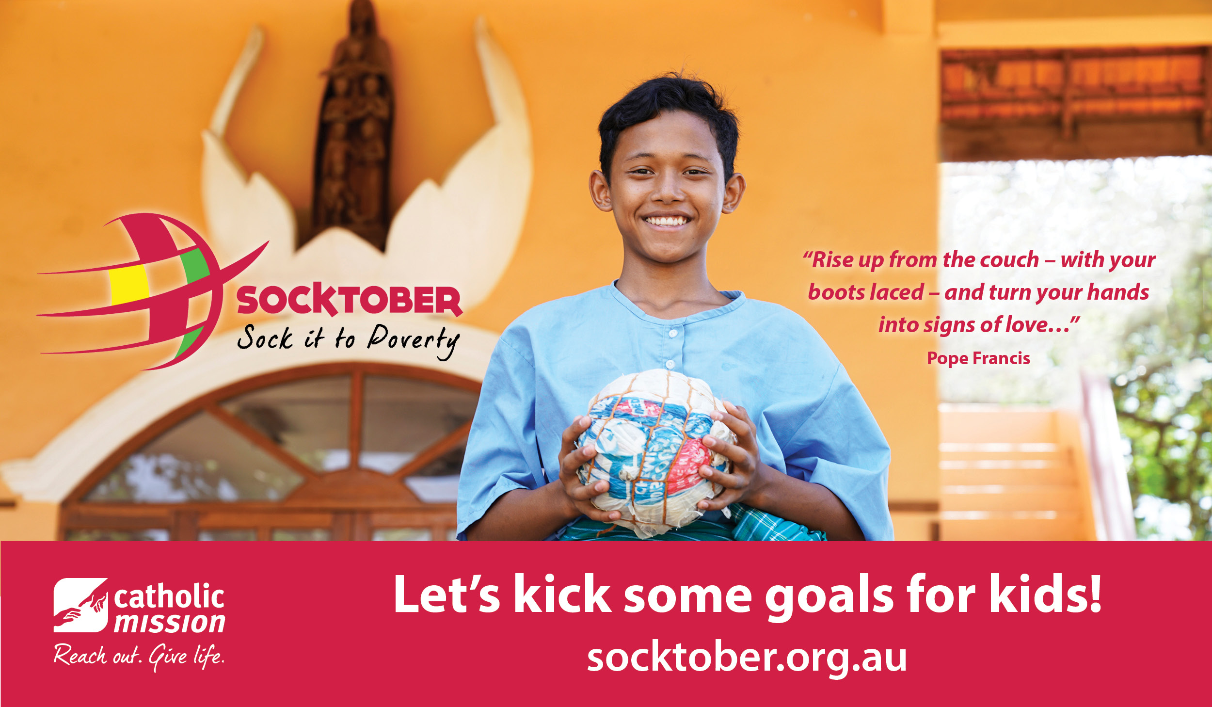

**Let’s sock it to poverty!**

**Have you registered yet?**

This year our school is participating in Socktober to kick some goals for kids in need around the world.

To help them join in the fun and make a difference, please register your child as a *Socktober Star* today, and start them on their mission journey.

**REGISTER TODAY!**

**socktober.org.au**

