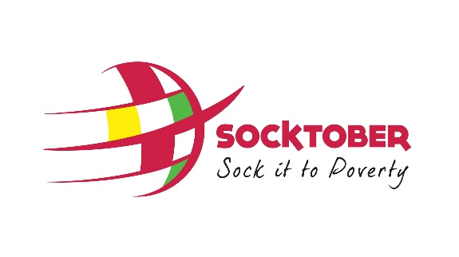
SAMPLE NEWSLETTER – SHORT VERSION

We are very excited to be participating in Socktober this year and helping our students to Sock it to Poverty!
We need your help! We’ll be kicking off our activities soon, so we invite all parents to register their children as Socktober Stars at the link below so they can be part of it:
www.socktober.org.au/[insertschoolname]
Don’t forget to link your the page to your child/ren’s school house team on the site.
Should you choose, please consider helping your child set a target and fundraise for vulnerable children to fulfil their basic needs. Once registered, students can ask their friends and families to sponsor them in tackling each week’s activities and kicking goals for kids around the world.
We also would love to have parents come along and support the children on our Socktober Event Day. We’d love to see you there. Please email [insert name] if you are available. Thanks for support your child/ren and we look forward to updating you on our Socktober journey!

