**[INSERT SCHOOL LOGO]**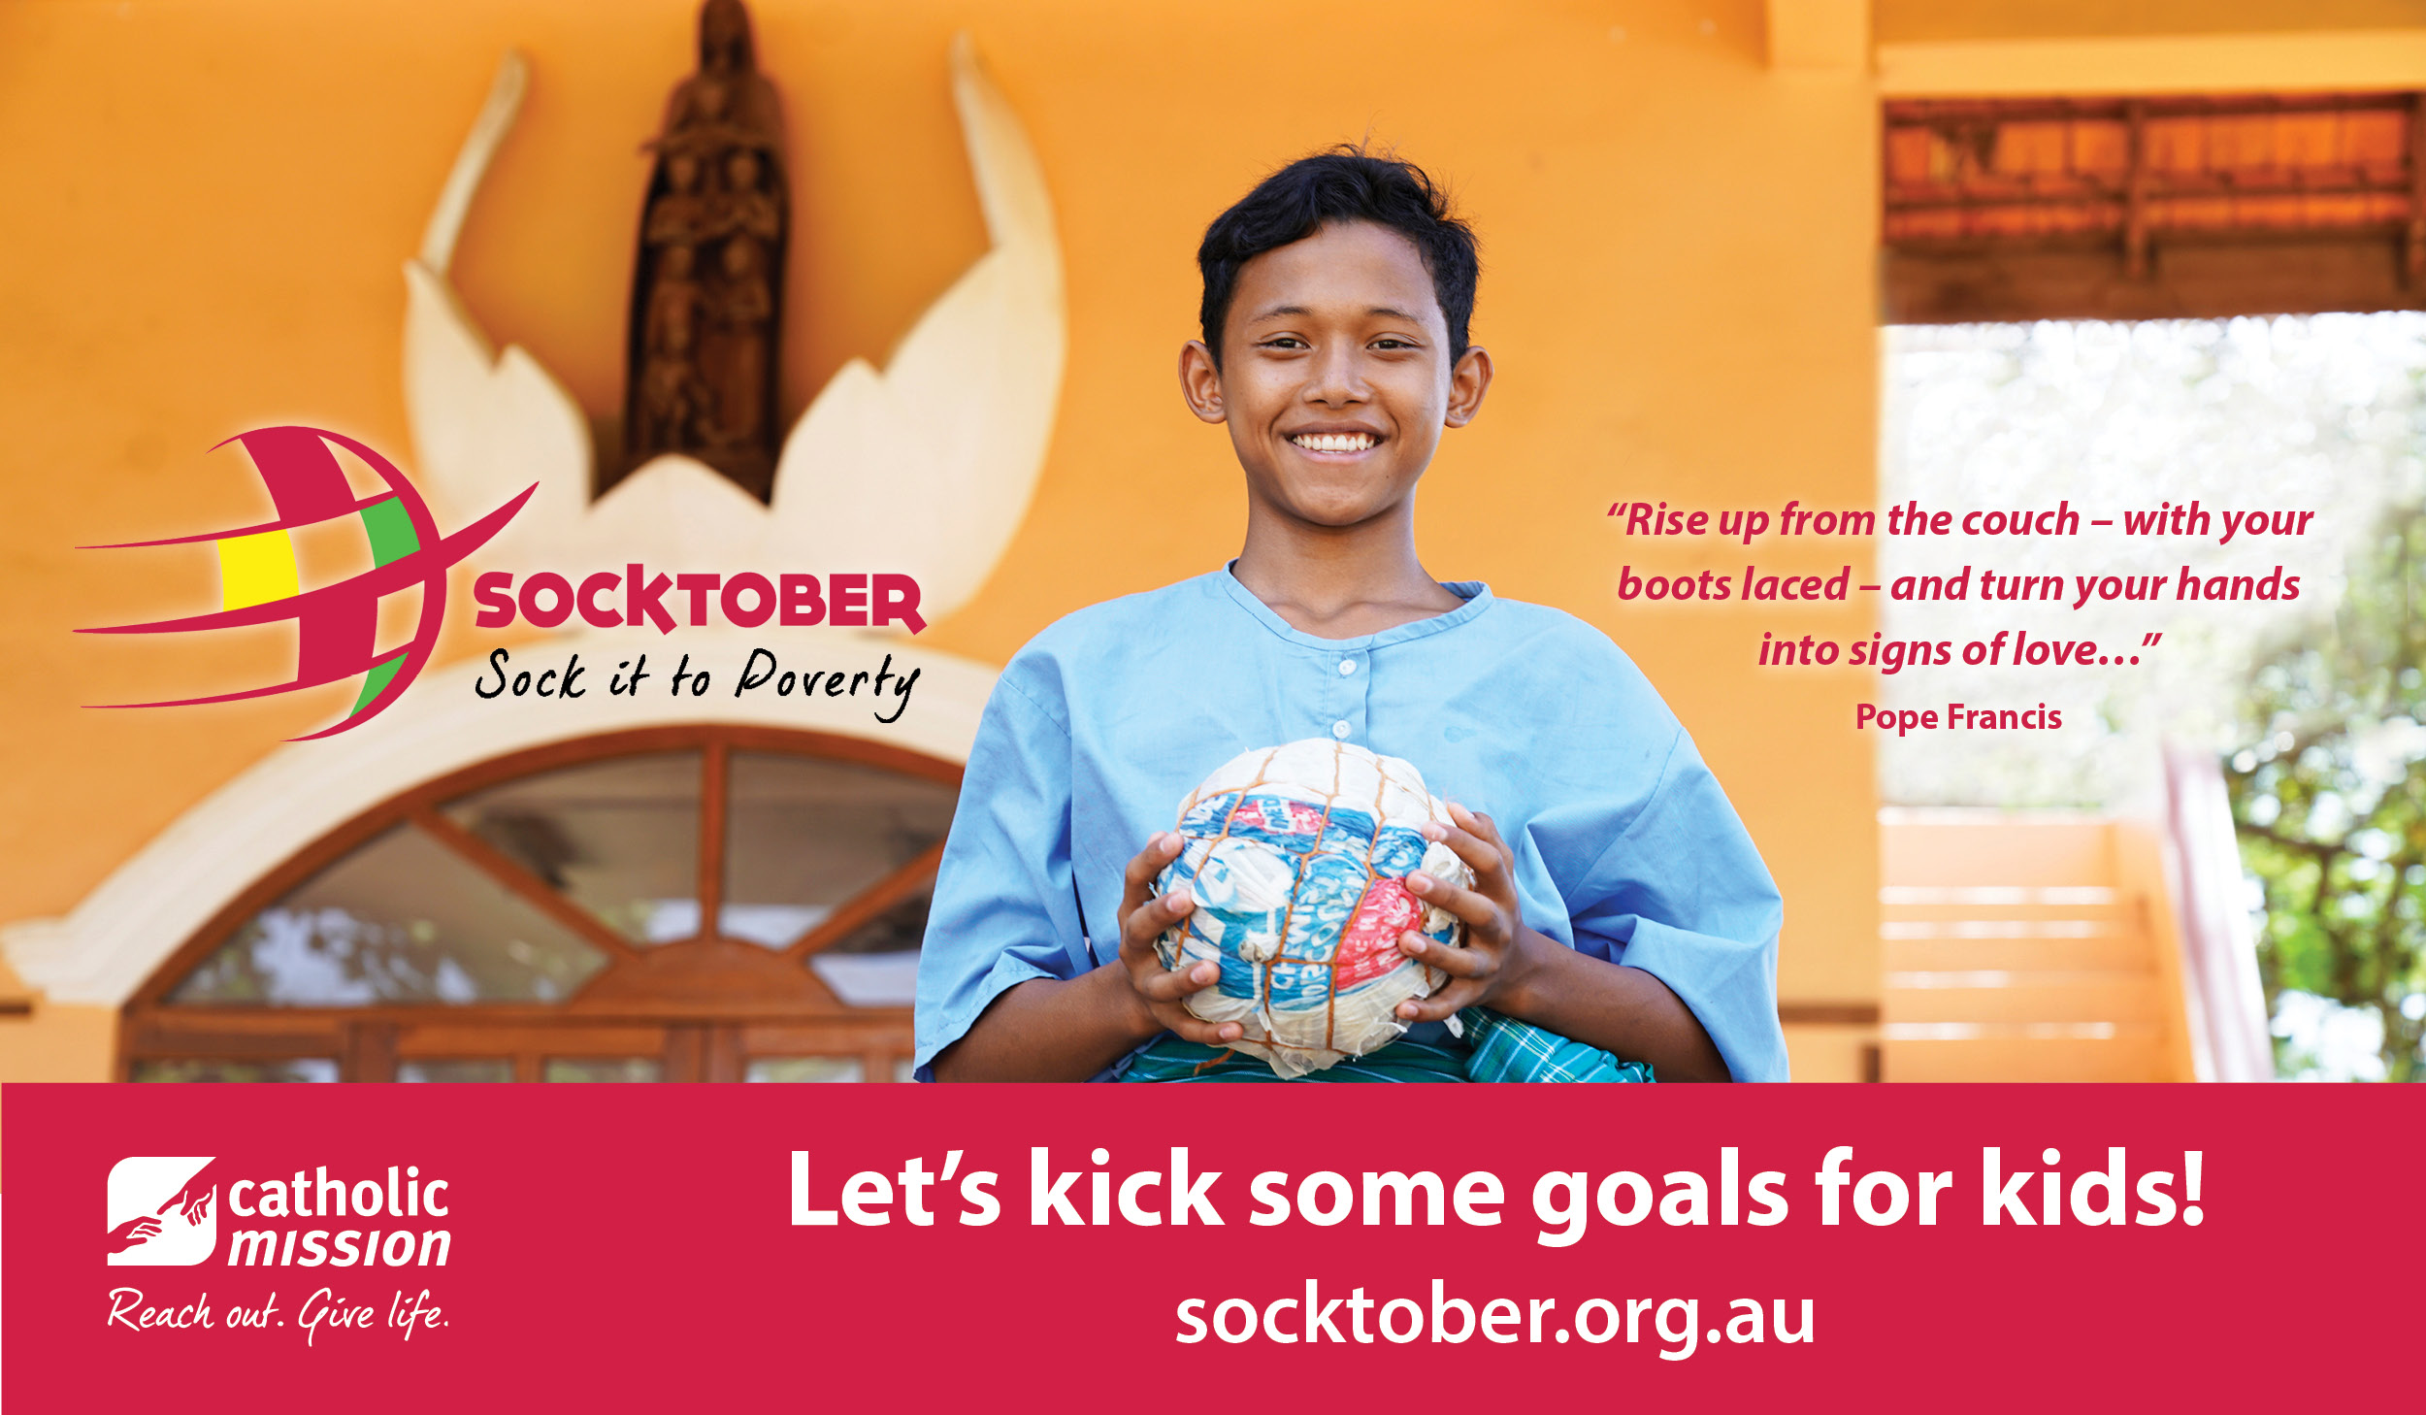

**Let’s sock it to poverty!**

**[Event Day Date]**

Please wear your school sports uniform and your favourite coloured socks.

We would love parents/carers to join us.

[INSERT ADDITIONAL TIME, LOCATION, ACTIVITY DETAILS]

*Don’t forget to register online:*

**socktober.org.au**

